## Nielsen Heuristics Evaluation Form (make as many copies as you need)

**1. What screen of the UI are you looking at (attach/paste a picture/screenshot):**

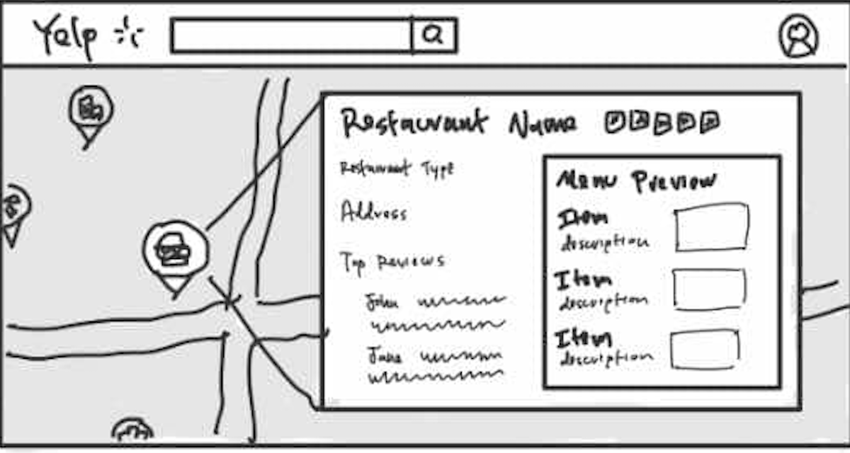

**2. Evaluate each heuristic below for this screen. Feel free to draw circles and arrows around the above screen shot.**

* Visibility of System Status:

**The map view provides good visibility of the user's current location and nearby restaurants through map pins, offering clear feedback about what is being displayed. However, there is no indication of loading or processing when interacting with elements like filters or menus.**

* Match Between System and Real World

**The interface uses real-world metaphors effectively, such as pins on a map to represent locations. Information like "Restaurant Type," "Address," and "Top Reviews" mirrors how users think about exploring restaurants.**

* User Control and Freedom

**Users can click on pins to view restaurant details, giving them control over navigation. However, the interface lacks a back button or undo option for returning to the map or previous states.**

* Consistency and Standards

**The use of a map with pins is consistent with many similar applications, ensuring users are familiar with the interface. However, the menu preview layout could be more consistent in spacing and alignment.**

* Error Prevention

**The design does not show proactive mechanisms to prevent errors, such as highlighting non-interactive areas or providing confirmation prompts when exiting the details view.**

* Recognition Rather Than Recall

**The map pins and preview panel reduce the need for memory recall. Details like restaurant name, type, and menu preview are presented visually, allowing for easier recognition.**

* Flexibility and Efficiency of Use

**The design caters well to casual users but lacks shortcuts or advanced features like filters for power users. Adding options like sorting pins by distance or rating could improve efficiency.**

* Aesthetic and Minimalist Design

**The design is functional but could be more minimalist. The map and panel coexist without overwhelming the user, but elements like the "Top Reviews" section might benefit from improved spacing.**

* Help Users Recognize, Diagnose, and Recover from Errors

**No visible error messages or diagnostic tools are present. Including a fallback for map errors (e.g., "No restaurants found in this area") would improve the user experience.**

* Help and Documentation

**The interface lacks help options or tooltips to guide users unfamiliar with map navigation or features. Adding a small help icon or guide would enhance usability.**